|  |
| --- |
| TALKBOX  TESTING |
|  |
| April 3, 2019  VERSION 2.0  GROUP 9  Authored by: Neharika Puri, Yonis Abokar, Eric Pham |

TABLE OF CONTENTS

1. Introduction …………………………………………………………………………………………………………… 3
2. Functionality ………………………………………………………………………………………………………….. 3
3. System Requirement ……………………………………………………………………………………………… 3
4. How to get started ………………………………………………………………………………………………… 4
   1. Download as JAR..……………………………………………………………………………………… 4
   2. Open in an IDE…………………………………………………………………………………………….. 4
5. Configuration App ………………………………………………………………………………………………….. 4
   1. Create a Button………………………………………………………………………………………….. 5
   2. Make a Profile ……………………………………………………………………………………………..5
   3. Record Audio………………………………………………………………………………………………..6
   4. Add Recordings to Button …………………………………………………………………………….6
   5. Import Audio File ………………………………………………………………………………………….7
   6. Launch your Profile………………………………………………………………………………………..7
   7. Load Profile…………………………………………………………………………………………………..8
6. Simulator App ……………….……………………………………………………………………………………….. 8
   1. Use the buttons and hear audio ………………………………………………………………… 9
7. Help
   1. Help with JAR……………………………………………………………………………………………..9
   2. Help with IDE………………………………………………………………………………………………10
8. **Introduction**

The purpose of this application is to virtually stimulate a TalkBox that will later be simulated on Raspberry Pie. The software in general will aid in communication for the users, who currently struggle with it due to the medical reasons. The overall layout is interactive and easy to use.

The software consists of three applications:

1. TalkBox Simulator
2. TalkBox Configuration
3. TalkBox LogBook

The configuration will provide the users with a GUI App environment and show different functionalities available.

The Simulator will provide the users with buttons (that they will have a freedom to create) that can be used to aid communication.

The LogBook will keep track all the actions of the user and will also help for QA later, in order to improve the software and keep track of what is used most by the users.

2.0 Functionality

The software provides the user with much more functionalities than a usual Sound Generating Device (SGD). Some of them are as follows:

* Choosing the number of buttons for your screen
* Making a profile
* Using Pre-recordings
* Uploading audios from device
* Putting images on the buttons
* Record your personal audio/sound
* Adding recordings to the buttons
* Adding buttons to your profile
* Launching your profile, with named buttons
* Personalized profiles

3.0 System Requirement

This software will operate on a desktop/laptop device. It will require a supporting Operating System (OS). Moreover, it will also require JRE 8 and higher versions. The basic use of the software will not require an internet connection, but accessing documentation might require a stable internet connection.

The hardware required will be a microphone to allow personal recordings. Also as this software is computer based and there is no hardware buttons the user will need a mouse to interact with the system.

4.0 How to get started:

*Preferred but optional steps

4.1 Download as a JAR

1. Create a directory to hold the JAR files

2. Go to https://github.com/neharikapurieng/TalkBox

3. Click, download the JAR

4. Save jar to the directory made

4. Go to saved location and extract TalkBoxConfigurator.(It should extract to new folder called TalkBoxConfigurator).

Method 1. Double Click

5. Double Click the TalkBoxConfigurator JAR file to run

6. After the preferred configuration is made, click launch

7. Simulator app will launch

8. Double click the TalkBoxSim to launch simulator at any time

If unable to open, refer to Method 2 or refer to section 7 for help

Method 2. Run using commands

5. Open command Prompt or Terminal depending on operating system

6. Navigate to the directory holding the jar files

7. Type java -jar TalkBoxConfiguration.jar to run

8. After configuration is made click launch

9. Simulator will launch

8.Type java -jar TalkBoxSim.jar to run at any time

If unable to run, refer to section 7

4.2 Open in an IDE

1. Go to https://github.com/neharikapurieng/TalkBox

2. Click, download the project.

3. Open an IDE of your choice, and open this project on it.

4. Run the project.

If unable to run, refer to section 7

For Visual Representation visit section 7

5.0 Configuration App

1. When you run the application. The configuration app will display.

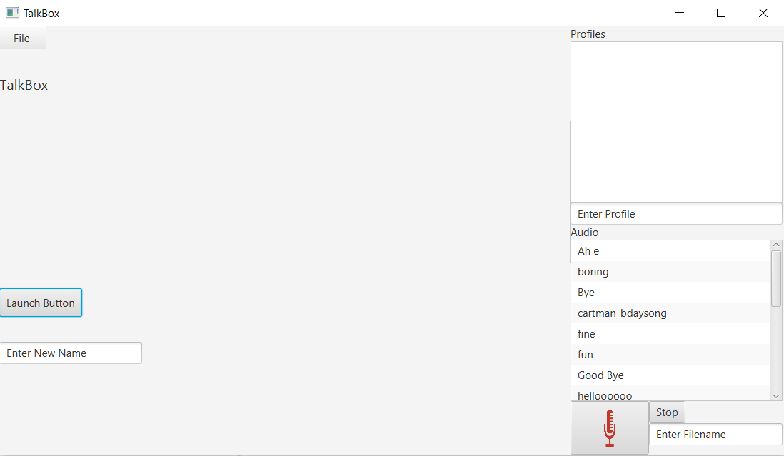

5.1 Make a profile

The first step is to make a profile.

1. On the right side you will see “Enter Profile, write your profile name there and press enter.

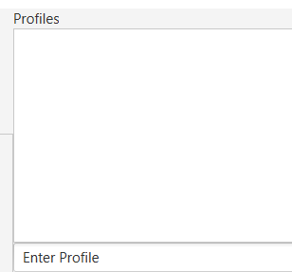

5.1 Choose Audio

Now add audios/ buttons to your profile.

1. On the right side you will see different pre-recorded audio, press the ones you want and they will be automatically added to a button, and the buttons will be added to the profile.

5.3 Record Audio

On the right bottom corner, you will see a list of pre-recorded audios. In order to record your own audio, follow the following steps and you will see your audio in the list.

1. Write a name of the audio, in the box that says “Enter Filename”. By clicking on the box and entering the name then press enter.
2. Press Record, and say what you want to, then press stop.
3. Your audio is in the list and ready for you to choose !

5.4 Adding images to the button

Now that we have the buttons, you can add images to it !

1. Right click the button
2. Select “Load Image” and select the image from your device

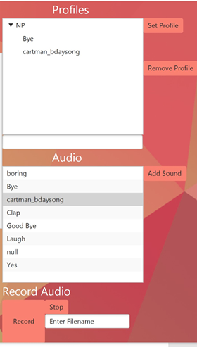

5.5 Import Audio Files

If you want to import your own audios and add them the audio list, follow these steps:

1. Click File
2. Click Import Audio
3. Navigate through personal directories
4. Add the wav file
5. The wav file should appear at the bottom of the list of audio files.

5.6 Rename Buttons

If you want to rename the buttons then:

1. Write the new name of the button in the text field below the “Launch Button”
2. Right click on the button and click Rename, the name will be changed

6.0 Simulator App and Launching your profile

Now, that your profile is ready. Press the button called “Launch Buttons”

1. In the simulator, click “Profiles” and choose your profiles
2. The buttons and audios inside that profile will load

6.1 Use the buttons and hear audio

1. On the right side of this app, you will see your profile name. Under it, you will also see a Set Profile button, click this button and your buttons with the audio will appear.

2. Press any button you wish, and you will hear an audio. (ps. Make sure your speakers are on)

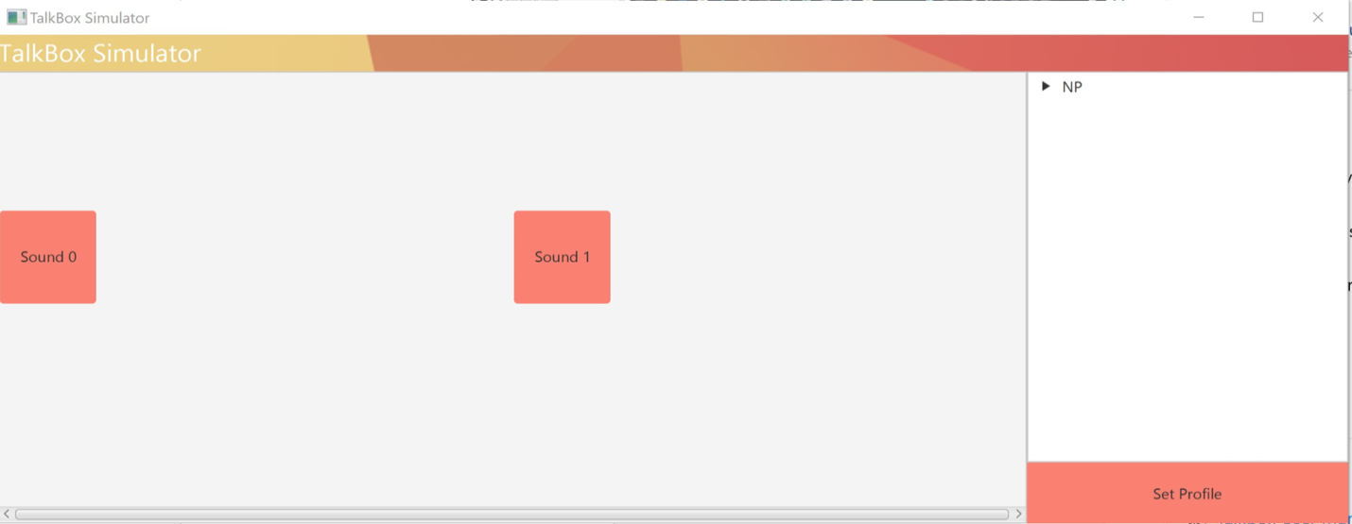

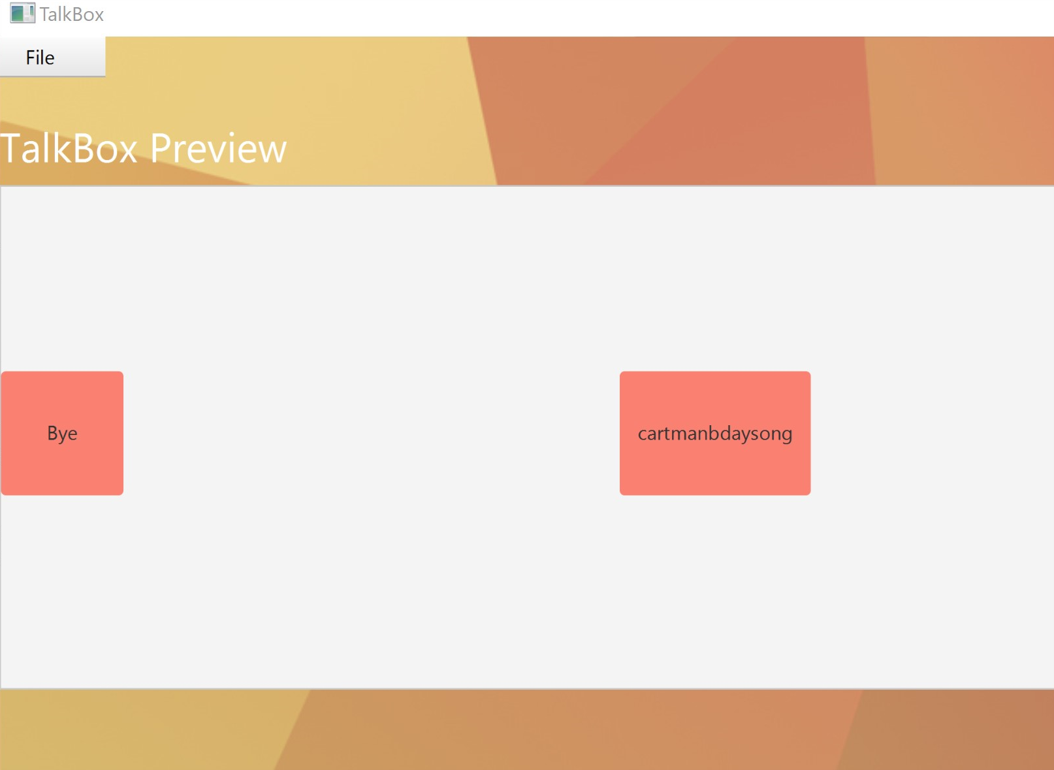

Section 7 Trouble-Shoot

7.1 JAR  
If the JAR file is unable to run do the following steps

1) Make sure the TalkBoxConfiguration JAR file is extracted. A visual can be seen below.

2)Make sure the extracted TalkBoxConfiguration directory is located in the same directory as its JAR file

3)Make sure you have JavaFX installed

4) <https://www.youtube.com/watch?v=o6wUGzJ6PwA> Watch this video for visual help

7.2) IDE

1)Make sure there are no errors in the code

Visual: https://www.youtube.com/watch?v=5smwqeQ96-M&feature=youtu.be&fbclid=IwAR2z8lYq-A__UcnB0jgtMmZiZ8MuqMZzHLNHvSrj0hC-s2ufvEoNuOPhLus